Depression Awareness and

Management in the Workplace

A person who has a diagnosis of depression is considered disabled under disability discrimination legislation in NI. Where there is an impact on the person’s ability to carry out their duties, the duty to make reasonable adjustments is applied. This duty applies to every aspect of the job from designing job criteria, advertising the post, recruitment and all aspects of work including retirement, redundancy or dismissal.

**Reasonable adjustments** will help overcome the difficulties that an employee with depression may have in performing their job. Employers should liaise with the disabled person and relevant experts, such as Occupational Health (OH) or disability advisers, to establish what difficulties the person is experiencing and how they impact on their ability to undertake their duties. In addition, this will ensure that reasonable adjustments are identified, implemented and reviewed.

Research shows that work is an important part of an employee’s recovery from depression so, where possible, remaining in work should be the aim or, if the employee is absent, getting them back as quickly as possible with adjustments in place.

In order to identify and resolve any difficulties, make sure the discussion takes place as early as possible and with the right person/people involved. This is usually a line manager and/or HR personnel:

* Create an open, supportive environment - encourage employees to seek support
* Follow the organisation’s reasonable adjustment policy/good practice procedure
* Ensure all employees are aware of this policy and practice
* Put the policy into practice as early as possible, with flexibility
* Identify an employee who is well trained in disability discrimination legislation and associated good practice to coordinate the reasonable adjustment procedure, usually a line manager or HR professional
* Ensure a consistent approach
* Ensure confidentiality
* Liaise with HR
* Keep the disabled person involved in every step of the process
* Engage experts for:
  + Assessment
  + Identification of adjustments
* Review adjustments’ implementation regularly

When considering the reasonableness of adjustments, consider:

* How effective would they be in overcoming the difficulties experienced by the disabled person performing their duties
* The practicality of adjustments
* Cost and resources available
* Disruption caused
* Effect on other employees
* Adjustments made for other disabled employees
* Co-operation of the person

Remember that all disabled people should be treated with consideration of their individual circumstances. Every person with a diagnosis of depression will have different strengths as well as potential challenges. Employers sometimes mistakenly believe that treating all employees in exactly the same way constitutes equality, but this is not the case. Adjustments to policies and practices should be individually tailored.

**Common workplace adjustments for people with depression:**

* Adjusting workplace procedures, e.g. recording absence under disability-related leave and not sickness absence, being flexible about applying triggers
* Reducing hours of work (temporarily or permanently)
* Redeployment to a different position, e.g. from customer facing to back office
* Moving the employee to a different location and/or allowing them to work from home
* Reallocating some responsibilities/duties that the employee finds difficult due to depression
* Allowing time and support for rehabilitation/treatment, e.g. counselling, CBT
* Training on new role, equipment, new ways of working
* Changing start time or finish time or working patterns to accommodate issues, e.g. to avoid peak travel times, allow for medication effects to settle
* If employee has been off work, allowing a phased return to build up the person’s mental and physical resources
* Providing/facilitating a buddy/mentor or access to other services during working hours
* Allowing an advocate or person who provides emotional support to attend meetings as required
* Allowing the person to communicate in their preferred method, e.g. via telephone or email
* Facilitating the use of memory aids such as reminders
* Allowing the person to work in a quiet area as required to aid concentration
* Facilitating regular breaks if needed to help with self-management techniques

**The effects of depression and how employers can help:**

You may not know the exact depression diagnosis, in terms of which criteria the employee meets and to what extent. However, where you see how the effects are being expressed in the workplace (in accordance with the criteria below), together with further discussions with the employee, you can be part of the positive environment and support structure that helps the employee work through their depressive episode and beyond. Identifying, implementing and reviewing reasonable adjustments will be critical. In addition, good practice measures, a disability positive culture and steps to highlight mental health awareness for all will also help limit or even prevent episodes. The hints and tips below are useful for encouraging and assisting the person with depression. However, it is essential that the person’s diagnosis is treat confidentially and their privacy is respected. They may not wish to discuss such personal matters, however, this advice is useful where there is a colleague who has a positive relationship with the employee who would value their input.

**Low mood or sadness:**

Respect that an employee’s mood is not what they usually present with and that their mood can fluctuate, but do not avoid interaction with them or wait for them to reconnect with you when they “seem more like themselves”. Encourage an open and welcoming workplace, with key employees “checking in” with the person on a regular basis. A “How are you?” and feeling encouraged and listened to can go a long way. Allow access to a private room as and when needed but, even better, have one established on a permanent basis (space permitting) and this can be used by, and will be beneficial to all, employees, including those with other disabilities such as autism or anxiety disorders. Make sure the employee is still invited to participate in any fun outings, team activities or meetings and not penalised or made to feel bad about saying no.

**Loss of interest in activities and in life:**

Ask the employee about what activities they are doing, particularly if they have hobbies that they are usually passionate about but may have stopped talking about, or are saying that they are going to give them up. Remind them that this is something they have loved doing in the past and that they will enjoy again, and that doing things they enjoyed before is helpful for the depression they are currently experiencing. Remind them also that activity is key to overcoming depression and that focusing on how they will feel afterwards is important rather than how they feel right now.

**Loss of energy:**

Consider any adjustments (such as those mentioned above) that could be put into place to help the person manage lower energy levels, such as reduced hours or workload. Low energy affects a person’s mood and ability to concentrate for any length of time, so ensure breaks are taken and perhaps allow some additional short breaks as needed. Be patient and understanding, and if certain tasks are particularly taxing, consider swapping these for others for a short-term period or provide an additional employee to assist.

**Weight loss or gain due to a change in appetite:**

Make being and staying healthy part of your organisation’s ongoing wellbeing strategy with goals that are available to and achievable for all employees. Start a healthy eating and physical health initiative within the workplace using intranet, employee boards, guest speakers at events etc. Share healthy eating and physical activity literature. Trial a healthy eating break, perhaps consider providing fruit and water to employees at break time, even one day per week, letting them experience the difference for themselves. Provide water fountains if possible and encourage good hydration throughout the day. When initiatives have been in place, should someone experience depression, it is easier to resume a healthy workplace habit with encouragement from team members rather than take one up for the first time. It is also easier if it is already a cultural norm.

If you notice that an employee is skipping meals and saying things like “I’m not hungry” or avoiding breaks, make sure they are included in break and lunch times with others and encouraged to eat (even a little) reminding them that this will help keep energy levels up and help their mood.

**Self-criticism:**

This is a very common characteristic with depression and only serves to lower a person’s mood, energy and social engagement. The person needs to be reminded that this is the depression talking and just because they “hear” it does not make it true. Time to challenge the inner critic and employers can help!! Employers can provide some “evidence” that can be used to build positive beliefs.

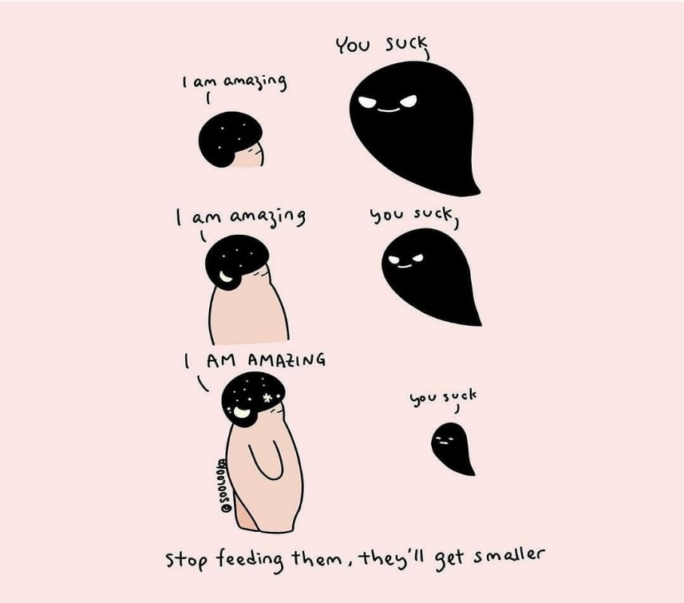

When an employee is putting themselves down about their ability to do their work or continually going over mistakes or failures, help (i.e. other team members and managers) them to see that they are focusing on the negative (if it actually exists at all), that this is an opportunity to learn and problem solve, moving forward. Remind them, using **concrete examples,** of past/current achievements that they have contributed to and how they make a valuable contribution to the team. You can do this face-to-face in one-to-one meetings, using one that is already usual practice for you, e.g. weekly update, but if needed, schedule one and introduce the subject matter sensitively and with care:

“I have noticed lately that you have been putting yourself down a lot….”

“I have overheard you saying that you were the reason the project didn’t produce the expected results…”

You can also email the employee if they find face-to-face difficult.

Make praise for jobs/tasks well done a part of your usual management practice (for all employees) and set the example of dealing with and resolving mistakes with a calm, professional and resolution-focused approach. This can help make sure employees are less apprehensive about making mistakes in the first place and/or feel they can approach managers with problems.

**Feelings of hopelessness:**

Listen. Support. Encourage. Remind the employee that depression can make things seem hopeless when this is not the case and that when things have seemed this way before, solutions were always found and difficult times always pass.

Should the workforce be experiencing stressors and uncertainty due to the economic climate, takeover, redundancies, or have more than the usual workloads, take extra care with employees who are experiencing depression (anxiety too). Share positive, solution-focused information, e.g. case studies on the intranet, workshops, online training etc., about the current situation and how the organisation can work through this difficult time. Use past examples and take expert advice about how to do this. Share and celebrate progress made, no matter how small the achievement.

Should an employee express thoughts of suicide, say that they no longer wish to live, that everyone would be better off without them around or communicate they have a suicide plan, DO NOT LEAVE THEM ALONE. Stay with them - get another employee to support you if needed - listen, encourage the employee to talk to a colleague they are close to (if that is not you), a family member/loved one and/or get professional help, e.g. arrange a GP appointment and have someone from the workplace bring them (or get a family member to accompany them) to that. Give the employee details of organisations that are there to help and if there is no family member available at this moment to take over, encourage the employee to make a call to such an organisation, making a room available where they will be undisturbed and have someone available to support them once the call is over:

**Lifeline: 0808 8008000**

**Samaritans: 028 9066 4422**

Following this incident, follow up on what has occurred. Do not assume these feelings have gone away. Keep encouraging the employee to talk or avail of support as and when needed.

**Physical complaints:**

Depression often expresses itself physically in the body with persistent complaints like muscle soreness, headaches, backpain, skin complaints, stomach, bowel and digestive problems. It can also exacerbate conditions that are already present that have an identifiable organic cause. A person may need to visit their doctor or need time during the day to manage these symptoms, so try to accommodate these needs by allowing additional time for a doctor’s appointment (preferably at the start of or end of the day if possible) and/or encourage additional breaks during the working day.

**Difficulty concentrating and making decisions:**

The employee may not ask for help, so make asking for help the organisational norm. Communicate sources of help explicitly throughout the organisation as a preventative measure as well as when someone is experiencing these difficulties. Identify someone/others in the team who the person can ask for advice or run decisions by, before the final decision is made/steps are taken. This person could be a member of the employee’s team who they have a good working relationship with, or a more formally established mentor, who can also be a source of support on an ongoing basis and beyond any depressive episode. Meet with the employee to discuss what decisions they make as part of their role and that they are finding difficult. Devise a step-by-step strategy to enable the employee to reach decisions (using past experience to guide if possible) that can then be brought to someone for a final check before passing on. The idea is to have the employee engage in the decision-making process and keep building confidence.

**Sources of advice and support for employers and employees with depression**

* For member employers, Employers for Disability NI
* Department for Communities can provide assessment and fund support as appropriate
* Disability organisations offering advice, specialist information and support
* OH, which can provide evidence on how the disability affects the job and possible adjustments. **NB:** Reassure the person with depression that OH is a support, not a punishment or to check up on them

This fact sheet was funded by the Halifax Foundation

Web: [www.efdni.org](http://www.efdni.org)

Email: [info@efdni.org](mailto:info@efdni.org)

Tel: 028 4062 4526